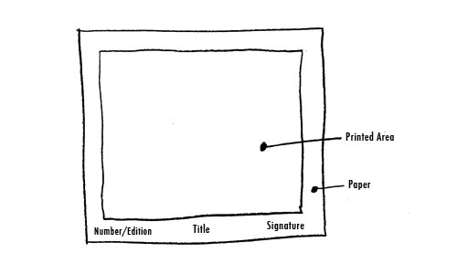

How are the following elements used or not used within your personal print?

Line:

Shape:

Form:

Color:

Texture:

Space:

Value:

