Perspective

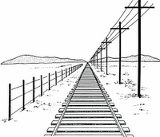
Objectives:
By the end of this unit, you should be able to…
…define perspective, proportion, horizon line, vanishing point and orthogonal line.
…illustrate a word in 1-point perspective.
…draw architecture using 2-point perspective.
…identify and demonstrate the four shading techniques.

Name: _____________________________________________________________________________
7th Grade Art Period ________________________________________

Perspective Definitions

- Perspective: ______________________________________________________________
  - One-Point Perspective: ________________________________________________
___________________________________________________________________
  - Two-Point Perspective: ________________________________________________
___________________________________________________________________
  - Aerial Perspective: ___________________________________________________________________
___________________________________________________________________
- Depth: __________________________________________________________________
  - Proportion: _________________________________________________________
___________________________________________________________________
  - Overlap: ___________________________________________________________
___________________________________________________________________
- Horizon line: _____________________________________________________________
- Vanishing point: __________________________________________________________
- Line: ____________________________________________________________________
  - Orthogonal line: _____________________________________________________
  - Vertical line: ________________________________________________________
  - Horizontal line: ______________________________________________________
  - Parallel line: ________________________________________________________
- Space: __________________________________________________________________
  - Negative space: ______________________________________________________
  - Positive space: _______________________________________________________
- Value: __________________________________________________________________
  - Blending: ___________________________________________________________
  - Hatching: __________________________________________________________
  - Cross-Hatching: _____________________________________________________
  - Stippling: __________________________________________________________

One-Point Perspective
Label:
- Horizon Line
- Vanishing Point
- Vertical line
- Horizontal line
- Parallel lines
- Orthogonal lines
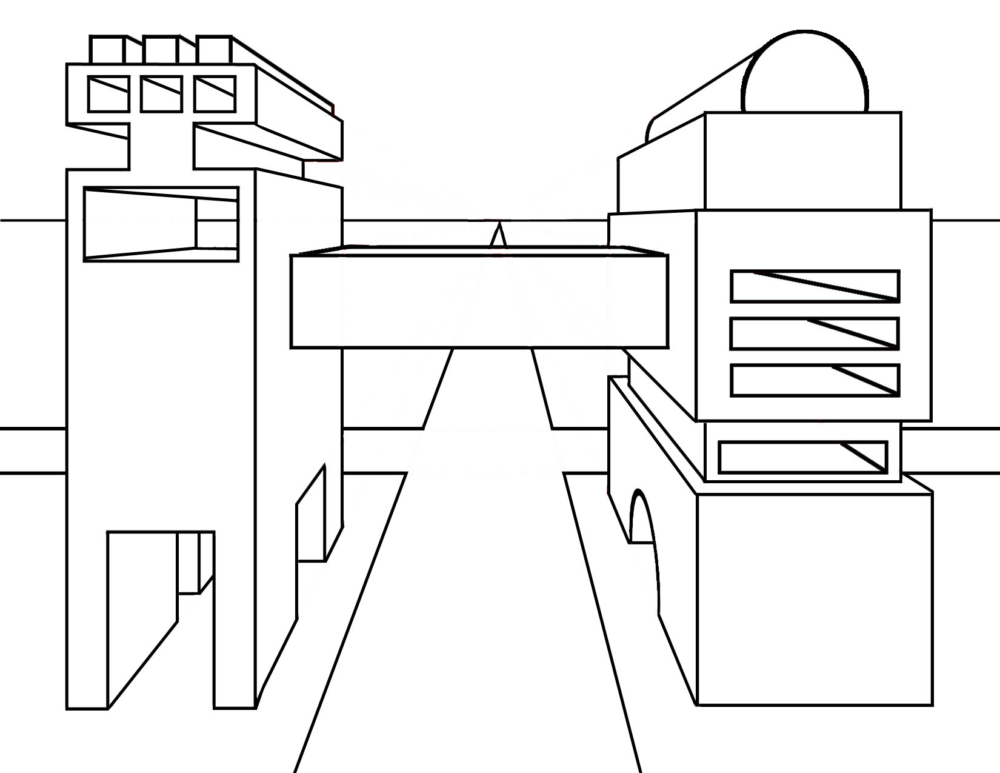

One-Point Perspective: Word Art (28 points)
At the end of this project, I will be able to…
- …define a noun.
- …illustrate a word using one-point perspective.
- …identify the vanishing point, vertical line, and orthogonal lines in a one-point perspective drawing.
- …use a ruler to measure and draw straight lines.
Project Guidelines:
☐Choose a 5-7 letter noun to illustrate in 3-D, one-point perspective letters: ___________________________________________
☐Use a ruler and the one-point perspective rules to draw your word in 3-D block letters.
☐Using the elements and principles of art, turn your word into a representation of itself using colored pencils.
i.e. If your word is “plant”, make it look like a plant.
If your word is “books”, give each letter characteristics of a book.
 | 4 | 3 | 2 | 1 | 0
Perspective:  Use of Line | All lines are straight and crisp. A ruler was used for ALL lines. | Most lines are straight and crisp. A ruler was used for MOST lines. | Some lines are straight and crisp. A ruler was used for SOME lines. | Few lines are straight and crisp. A ruler was used for FEW lines. | No lines are straight and crisp. A ruler was NOT USED for ANY lines.
Perspective:  Use of Vanishing Point | All objects are taken back to the proper vanishing point. | Most objects are taken back to the proper vanishing point. | Some objects are taken back to the proper vanishing point. | Few lines are taken back to the proper vanishing point. | No lines are taken back to the proper vanishing point.
Perspective: Parallel / Orthogonal Lines | All parallel / orthogonal lines are correct. | Most parallel / orthogonal lines are correct. | Some parallel / orthogonal lines are correct. | Few parallel / orthogonal lines are correct. | No parallel / orthogonal lines are correct.
Illustrated Word | Word is readable and is illustrated excellently. The illustration excellently relates to the word. | Word is mostly readable due to the illustrated aspect. The illustration mostly relates to the word. | Word is somewhat readable due to the illustrated aspect. The illustration aspect somewhat relates to the word. | Word is barely readable due to the illustrated aspect. The illustration aspect barely relates to the word. | Word is not readable due to the illustrated aspect. The illustration aspect does not relate to the word at all.
Elements and Principles of Art | Students utilized both the elements of art to illustrate their word: line, shape, space, form, value, texture, color, pattern, unity, etc. | Student utilized most of the elements and principles of art to illustrate their word. | Student utilized some of the elements and principles of art to illustrate their word. | Student utilized few of the elements and principles of art to illustrate their word. | Student has no understanding of how to utilize the elements and principles of art and/or made no attempt to utilize them.
Craftsmanship / Effort | Class time was used wisely. Extra time and effort went into the planning. Artwork has been created and maintained in a professional manner. | Class time was used wisely. A satisfactory amount of effort went into the planning. Artwork has been created and maintained in a somewhat professional manner. | Class time was not always used wisely but student got the project finished within the project parameters. Artwork was created and maintained with an attempt at neatness. | A majority of class time was not used wisely and tag was not finished with the project parameters. Artwork was not maintained with an attempt at neatness. | Class time was not used wisely and the student put in no additional effort. Artwork looks unfinished.
Creativity / Originality | Student has taken the technique being studied and applied it in a way that is totally his/her own. The student's personality/voice comes through. Everything is original. | Student has taken the technique being studied and has used source material as a starting place. The student's personality comes through in parts of the painting. Everything is original. | Student has copied aspects of their artwork from another source and/or there is little evidence of creativity, but the student has done the assignment. | Student has not made much attempt to meet the requirements of the assignment and/or a majority of the assignment has been copied from another source. | No creativity attempted and/or artwork is a direct copy from another source.
Two-Point Perspective

Label:
- Horizon Line
- Vanishing Point #1
- Vanishing Point #2
- Vertical line
- Orthogonal Lines
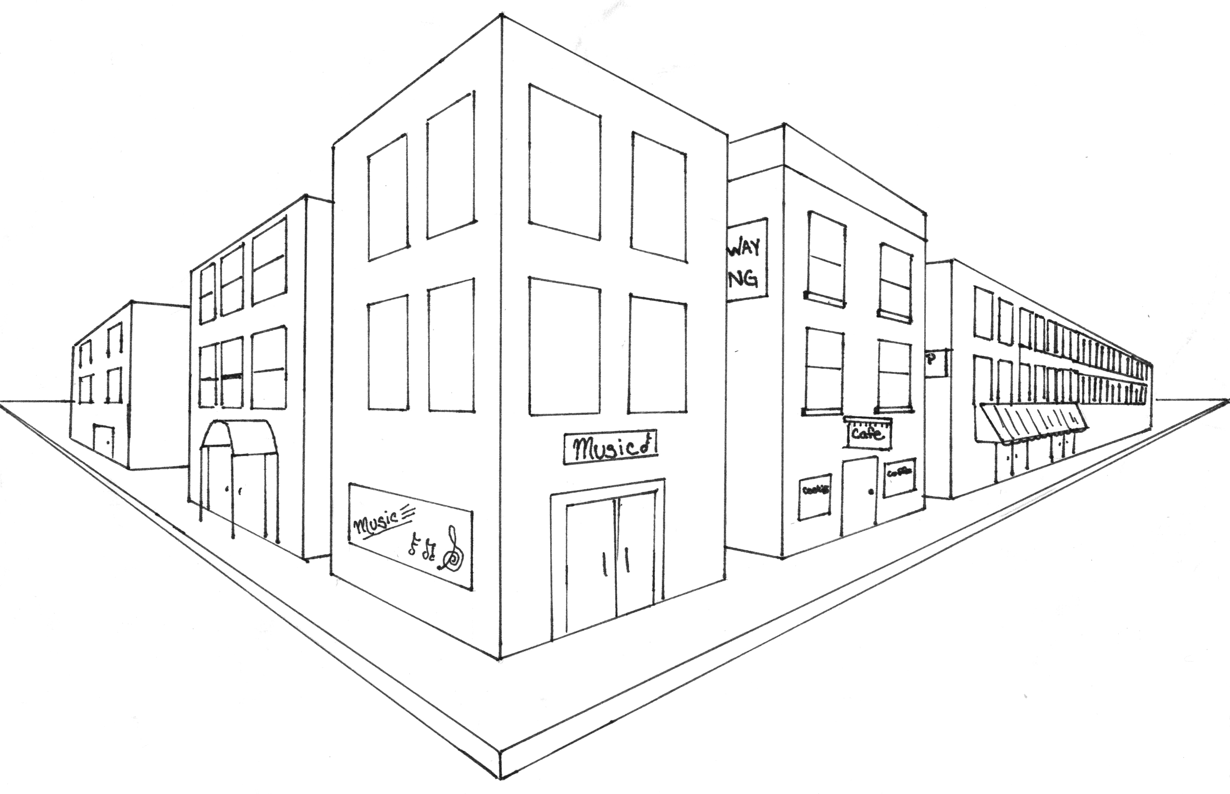

Value (8 pts. each)
Practice your value techniques using the value scales below. Try to get a good, gradual gradient of darks and lights as you fade from dark to light. The last box in every scale should be white.
Blending:

Hatching:

Cross-Hatching:

Stippling (use a marker for this technique):

Two-Point Perspective: Architecture (36 points)
At the end of this project, I will be able to…
- …utilize the rules of two-point perspective to draw architecture.
- …identify the vanishing points, vertical line, horizon line and orthogonal lines in a two-point perspective drawing.
- …use a ruler to measure and draw straight lines.
- …use value to create aerial perspective in my drawing.
Project Guidelines:
☐Choose a form of architecture to draw using two-point perspective (interior room, city, museum, bedroom, house, etc.)
☐Use a ruler and the two-point perspective rules to draw your architecture in pencil.
☐Neatly outline all your lines with a ruler and a black Sharpie marker.
☐Utilize the shading techniques to create aerial perspective in your drawing with ebony pencil.
 | 4 | 3 | 2 | 1 | 0
Perspective:  Use of Line  X 2 | All lines are straight and crisp. A ruler was used for ALL lines. | Most lines are straight and crisp. A ruler was used for MOST lines. | Some lines are straight and crisp. A ruler was used for SOME lines. | Few lines are straight and crisp. A ruler was used for FEW lines. | No lines are straight and crisp. A ruler was NOT USED for ANY lines.
Perspective:  Use of Vanishing Points  X 2 | All objects are taken back to the proper vanishing points. | Most objects are taken back to the proper vanishing points. | Some objects are taken back to the proper vanishing points. | Few lines are taken back to the proper vanishing points. | No lines are taken back to the proper vanishing points.
Perspective: Parallel / Orthogonal Lines  X 2 | All parallel / orthogonal lines are correct. | Most parallel / orthogonal lines are correct. | Some parallel / orthogonal lines are correct. | Few parallel / orthogonal lines are correct. | No parallel / orthogonal lines are correct.
Use of Value  (Blending, hatching, cross-hatching, & stippling) | Student correctly utilized all four of the value techniques to create aerial perspective. | Student correctly utilized three of the value techniques to create aerial perspective. | Student correctly utilized two of the value techniques to create aerial perspective. | Student correctly utilized one of the value techniques to create aerial perspective. | Student used no value in their drawing to create aerial perspective.
Craftsmanship / Effort | Class time was used wisely. Extra time and effort went into the planning. Artwork has been created and maintained in a professional manner. | Class time was used wisely. A satisfactory amount of effort went into the planning. Artwork has been created and maintained in a somewhat professional manner. | Class time was not always used wisely but student got the project finished within the project parameters. Artwork was created and maintained with an attempt at neatness. | A majority of class time was not used wisely and tag was not finished with the project parameters. Artwork was not maintained with an attempt at neatness. | Class time was not used wisely and the student put in no additional effort. Artwork looks unfinished.
Creativity / Originality | Student has taken the technique being studied and applied it in a way that is totally his/her own. The student's personality/voice comes through. Everything is original. | Student has taken the technique being studied and has used source material as a starting place. The student's personality comes through in parts of the painting. Everything is original. | Student has copied aspects of their artwork from another source and/or there is little evidence of creativity, but the student has done the assignment. | Student has not made much attempt to meet the requirements of the assignment and/or a majority of the assignment has been copied from another source. | No creativity attempted and/or artwork is a direct copy from another source.

